Date :30.12.25
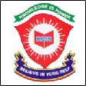
ROYAL OAK INTERNATIONAL SCHOOL
Sr. Sec. C.B.S.E. Affiliated (2025-26)

GRADE – III MONTHLY PLANNER 2026

Dear Parents, Greetings!

Please find the academic plan and activities for the month of January & Febuary

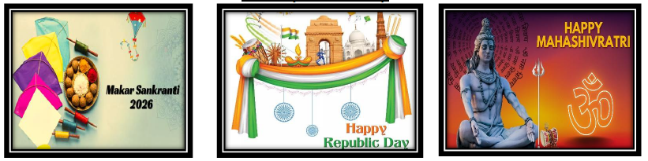

JANUARY & FEBURARY

ENGLISH | MATHS | HINDI
Ch-14 THE TWINKLE TWINKLE LITTLE STARS  GRAMMAR:-  - COMPREHENSION  - INVITATION NOTE | Theme-10 (Universe)  L-8 Money and Data Handlings  Revision | पुस्तक-साहित्य प्रकाश (भाग 4)  अध्याय - 14 चांद का कुर्ता  (पृष्ठ संख्या 37 से 41)  व्याकरण - भाग 2  अध्याय-10 पदान्वय और वाक्य विग्रह  अध्याय-11 रचनात्मक लेखन  (पृष्ठ संख्या 64 से 67)  दोहराई

E.V.S | G.K.
Theme -10 : Universe  L-10, Universe  Revision | Ch-37 Sports Stars And Their Equipments (Pg no. 49)  Ch-38 Cryptography (Pg no. 50)  Ch-39 It’s Playtime! (Pg no. 51)  Ch-40 Mini-Sudoku (Pg no. 52)  Test Paper-2 (Pg no. 53-54) /Revision

- Computer : Ch – 9: Introduction to Robots
- Practical : Coding on Scratch

ART & CRAFT | DANCE | MUSIC
Art - Page no: 34,39  Craft-Tri Colour Hand band | Preparation for Republic day function | Prayer, School Songs, Sargam Alankars and Instrument (Harmonium, Drum, Guitar & Casio)

Taekwondo | Yoga | Athletics | Kho- kho | Boxing | Football | Cricket | Basketball | Badminton | Chess | Skating
1. flexibility exercises  2.Back kick | 1Suptbajrasan  2Gomukhasan. | 1.Running Seating start technic | 1.Pole turn.  2.Chain kho. | 1.Punching with steps. | 1.Control and pass.  2.Dribbling.  3.Shooting. | 1. Bowling  2. Bating | 1. Control the ball with dribbling. | 1. Grip  2. Stance | 1.Strategy  2.Opening & Endgames. | 1.Put on your skating equipment.  2. Assume the right posture.  3. Walk like a duck.

Special Days/ Events | Holidays
- 26th Jan. 2026 – Republic Day | 1st to 15th Jan.2026 - Winter Break  14th Jan. 2026 - Makar Sankranti  15th Feb. 2026 – Maha Shivratri

Looking forward to a fruitful month of learning!

With warm regards,
ROIS

