

**ROYAL OAK INTERNATIONAL SCHOOL**

**SR. SEC. C.B.S.E. AFFILIATED (2025-26)**

**HALF YEARLY SYLLABUS OF CLASS VIII**

# ENGLISH

**Reading:** Unseen Passage, Poem **Writing:**

Message Writing, Notice writing, Bio sketch, Formal Letter, Informal letter, Story writing **Grammar:**

Adjectives, Verbs (Auxiliary Verbs, Transitive, Intransitive Verbs (Finite and Non – Finite), Voice, Tenses, Question tag, Phrases and Clauses, Conjunctions, Integrated grammar, Editing, Gap filling, Sentence reordering

**Literature :**

**Unit 1: Human Bonds**

Section 1: My Big Brother, **Section** -2 Thank You,Ma’am, Section 3: It was Long Ago (Poem) **Unit 2: Nurturing Nature**

Section 1: I Became a Great Friend of Animals and Birds, Section 2: The Ghost of the Mountains, Section 3:The Elephant and the Tragopan (Poem)

**Unit 3: Conflict and Hope**

Section 1: Pocahontas, Section 2:The Diary of a Young Girl, Section 3: The Song of Freedom **Pleasure Reading:**

Chapter 1 -The Merchant Of Venice

Chapter 2 - Romeo and Juliet

Chapter 3 - Twelfth Night

# MATHS

Chapter 1: Rational numbers.

Chapter 2: Linear Equations in one Variable Chapter -3: Understanding Quadrilaterals Chapter -4: Data handling.

Chapter -5: Square and square Root. Chapter -6: Cube And Cube Root.

# SCIENCE

Chapter 1: Crop production and Management

Chapter 2: Microorganisms: friend and foe

Chapter 3: . Coal and petroleum

Chapter 4: Combustion and flame

Chapter 5: Conservation of plants and Animals

Chapter 6: Reproduction in animals

Chapter 7: Reaching the age of Adolescence

# HINDI

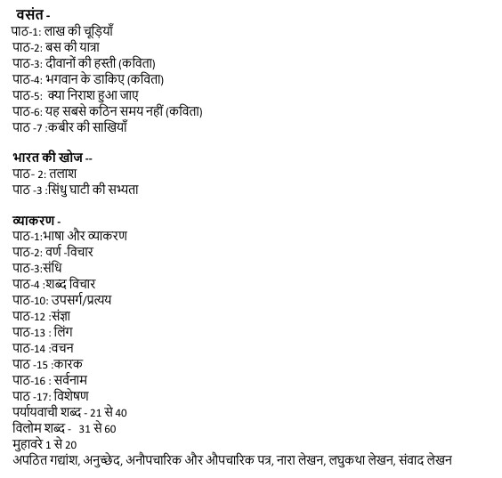

## SOCIAL SCIENCE

GEOGRAPHY :L-2 Natural Vegetation and Wildlife

:L-3 Agriculture

|  |  |
| --- | --- |
|  |  |
| POL. SCI. | : L-1 The Indian Constitution  : L-3 Parliament and making of Laws : L-4 Judiciary |
| HISTORY | : L-3 Ruling the countryside  : L-2 From trade to territory |

# SANSKRIT

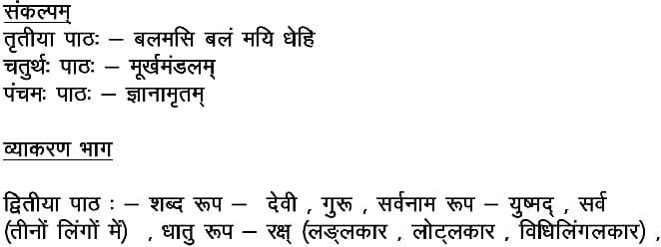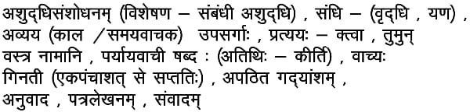

## FRENCH

**Section A** : Comprehension d’écrit

**Section B**: Boire verbe , Futur Proche, Mettez au pluriel, Prendre, Dire, Battre Lire et Faire

**Section C**: Les saions, Les animaux, La negation, Les expressions avec Faire

**Section D**: Leçon 4 et Leçon 5

## COMPUTER

Chapter – 3: AI in Real World

Chapter – 4 : Machine Learning

Chapter – 5 : AI Domains

Chapter – 6 : Future of Artificial Intelligence

## GENERAL KNOWLEDGE

|  |  |
| --- | --- |
| Chapter- 11: Upcoming Professions | P.no. 20 |
| Chapter-12 : Inventions of the 21st century | P.no. 21 |
| Chapter-13 : Human – Made Islands | P.no. 22-23 |
| Chapter-14 : Modern –Day Heroes Of India | P.no. 24-25 |
| Chapter-15 : World’s Engineering Marvels | P.no. 26-27 |
| Chapter-16 Vultures- : The Disappearing Heroes | P.no. 28-29 |
| Chapter-17 : World’s Most Amazing Natural Phenomena | P.no.30-31 |
| Chapter-18 : Best Universities in The World. | P.no.32-33 |
| Chapter-19 : Habits Of Successful People | P.no. 34-35 |

* **Test Paper-1**
* **Current Affairs & General Questions.**

## Art and craft

* Pencil Shading • Decorative Art
* Mix Media Art
* Nature Drawing