

**ROYAL OAK INTERNATIONAL SCHOOL**

**SR. SEC. C.B.S.E. AFFILIATED (2025-26)**

**HALF YEARLY SYLLABUS OF CLASS VII**

# ENGLISH

**Reading:** Unseen passages

**Writing:** Message, Paragraph writing, Diary entry, Formal and Informal letter,

**Grammar:** Punctuation, Sentence, Noun, Question Tag, Verbs, Finite and Non- finite Verbs, Tenses (Present, Past and Future, Editing (Error Correction), Articles**,** Pronouns, Adjectives, Active and Passive Voice

**Literature: Unit 1: Where Learning Begins**

1. A Hero-R.K. Narayan
2. The Taste of Watermelon-Borden Deal

The Flower-School-Rabindranath Tagore

**Unit 2: Wanderlust**

1. Atlantis
2. The Diary of a Space Traveller-Satyajit Ray

The Lake Isle of Innisfree-W.B. Yeats

**Unit 3: Real-Life Heroes**

1. The One Who Survived: Ada Blackjack Florence Nightingale-Emma Lazarus

**Pleasure reading:**

1. The Happy Prince
2. The Nightingale and the Rose
3. The Star-child

**Words of the Week (WOW)**

# MATHS

Chapter 1 Integers

Chapter 2: Fractions & Decimals

Chapter 3: Data Handling

Chapter 4: Simple Equations

Chapter 5: Lines & Angles

Chapter 6: The Triangle & its Properties

# SCIENCE

Chapter 1: Nutrition in Plants

Chapter 2: Nutrition in Animals

Chapter 3: Heat

Chapter 4: Acid, Bases and Salts

Chapter 5: Physical and Chemical Changes

Chapter 6: Respiration in organisms

Chapter 7: Transportation in Plants and Animals

# HINDI

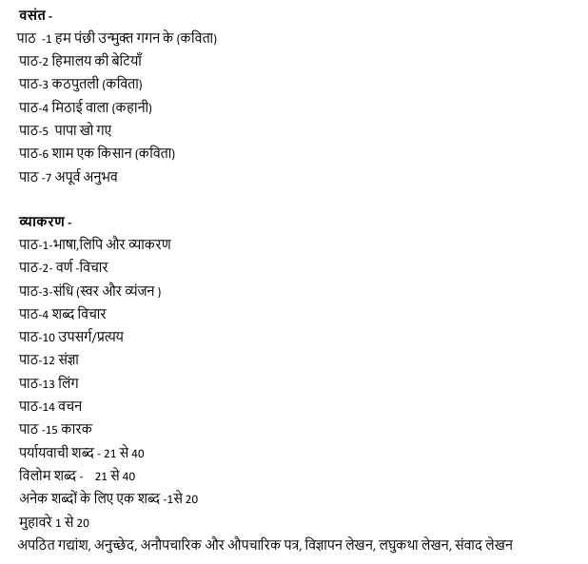

# SOCIAL SCIENCE

HISTORY : L-2 Kings and Kingdoms

L-3 Delhi: 12th to 15th Century

GEOGRAPHY : L-2 Inside Our Earth

L-3 Our Changing Earth

POL.SC. : L-2 Role of the Government in Health

L-3 How the State Government Works

# SANSKRIT

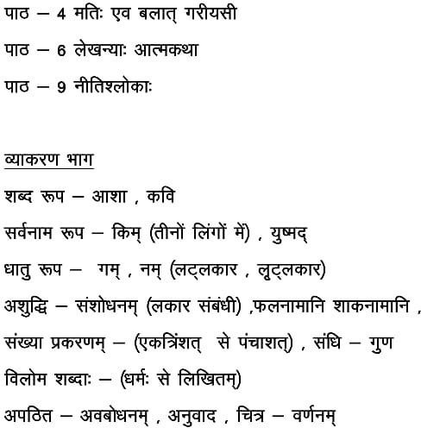

# FRENCH

**Section A :** Comprehension d’écrit

**Section B:** Quelle heure-est il?, Les articles définis , Verbe- Avoir, Mettez au pluriel, Savoir, pouvoir, falloir, vouloir, faire, aller, devoir

**Section C:** Le Formulaire d’inscription, Le poème - c’est l’été?

**Section D:** Leçon 4 Apprenons les professions, Leçon-5 Les couleurs

# COMPUTER

Ch – 3: Advanced Features of Excel

Ch – 4 : Coding and Flowchart

Ch – 5 : Advanced Makecode Arcade

# GENERAL KNOWLEDGE

|  |  |
| --- | --- |
| Chapter-11: World Famous Museums | P.no 18-19 |
| Chapter-12: Futuristic Solar Gadgets | P.no 20 |
| Chapter-13: Music Festivals In India | P.no 21 |
| Chapter-14: Unique Hotels | P.no 22 |
| Chapter-15: Effects Of Global Warming2 | P.no 23 |
| Chapter-16: World Of Reptiles | P.no 24-25 |
| Chapter-17: Cars Of Tomorrow | P.no 26-27 |
| Chapter-18: Challenge Accepted | P.no 28. |
| Chapter-19: Letter Sharp | P.no 29 |
| Chapter-20: Knowing Antarctica | P.no 30-31 |
| * **Test Paper-1** |  |
| * **Current Affairs & General Questions.** |  |

# Art and craft

* Nature Study
* Design Art
* Illusion Pattern
* Folk Art