

**ROYAL OAK INTERNATIONAL SCHOOL**

**SR. SEC. C.B.S.E. AFFILIATED (2025-26)**

**HALF YEARLY SYLLABUS OF CLASS VI**

# ENGLISH

**Reading:** Unseen passage, unseen poem

**Writing:** Message, Diary entry, Paragraph writing**,** Formal letter, Informal Letter

**Grammar:** Articles, Question tag, Tenses, Verb, Adverb, Adjective, Pronouns, Subject Verb Agreement, Punctuation, Sentences, Editing, Sentence reordering, Gap filling

**Literature:**

**Unit 1: Growing Up**

1. A Caterpillar called Matthew- Deepa Agarwal
2. The Classroom in the Train- Tetsuko Kuroyanagi 3. Foreign Lands (Poem)- Robert Louis Stevenson **Unit 2: Nature’s Bounty:**

1 .The Story of Amber Beads - Jane Andrews

1. The Banyan Tree – Ruskin Bond.
2. The Laburnum (poem) – Meera Uberoi

**Unit 3: Furs And Feathers**

1. Leah’s Pony – Elizabeth Friedrich
2. Attila- R.k. Narayan
3. The Duck – (poem) Harindranath Chattopadhyay

**Pleasure Reading :** L-1 to 7

Words of the week **(WOW)**

# MATHS

Chapter 1 Patterns in Mathematics

Chapter 2: Lines and Angles

Chapter 3: Number Play

Chapter 4: Data Handling

Chapter 5: Prime Time

# SCIENCE

Chapter 2: Diversity in the Living World

Chapter 3: Mindful Eating

Chapter 4: Exploring Magnets

Chapter 5: Measurement of length and Motion

Chapter 6: Materials Around Us

Chapter 11: Nature’s Treasure

# HINDI

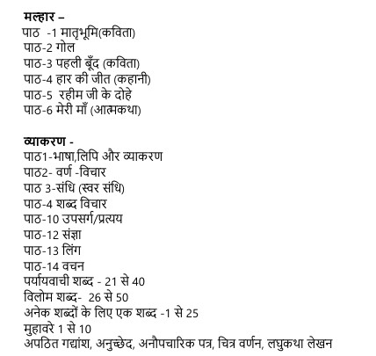

# SOCIAL SCIENCE

HISTORY : L-4 Timeline and Sources of History

L-5 India, That Is Bharat

GEOGRAPHY : L -1 Locating Places on the Earth

L-2 Oceans and Continents

CIVICS : L-8 Unity in Diversity, or Many in One

L-9 Family and Community

ECONOMICS : L-13 The Value of Work

**SANSKRIT**

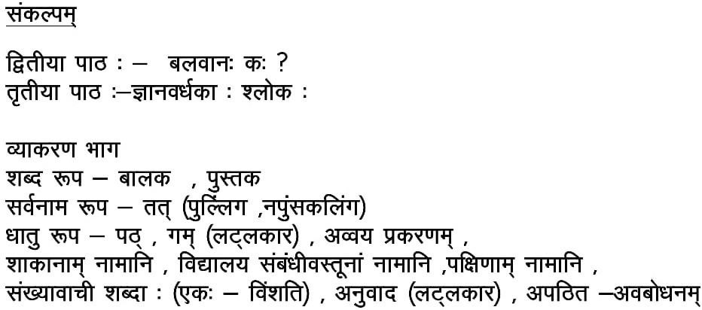

# FRENCH

**Section A:** Comprehension d’écrit

**Section B:** Verb Être Avoir , Les nombres 50-100, Le visage, Les articles indéfinis , Les Verbes En ER , Les adjectifs

**Section C:** Le poème: Mon chapeau , Le poème: Alouette une chanson, Les nationalités. **Section D:** Leçon-4 connaître les autres , Leçon-5 Les choses autour de nous

# COMPUTER

Ch – 3: Charts in Excel

Ch – 4 : Advanced Features of Powerpoint 2016

Ch – 5 : Algorithm and Pseudocode

# GENERAL KNOWLEDGE

Chapter- 11: Most Visited Cities P. no. 18 – 19

Chapter –12: Adventure sports Destinations in India P. no. 20 – 21

Chapter –13: Plastic Facts P. no. 22

Chapter –14:Theme Parks P. no. 23

Chapter –15: Heatstroke P. no. 24

Chapter –16: Dr Vikram Ambalal Sarabhai P. no. 25

Chapter –17: Co – relation P. no. 26

Chapter –18: Child Prodigies P. no. 27

Chapter –19 : Basic Yogasanas P. no. 28

Chapter – 20 : They Inspire Us P.no. 29

Chapter – 21 : Science Cartoons P.no. 29

* **Test Paper -1**
* **Current affairs and General Question**

# Art and Craft

* Nature Study
* Still Life
* Traditional art
* Scenery