Date: . .2023
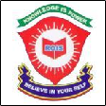
ROYAL OAK INTERNATIONAL SCHOOL
Sr. Sec. C.B.S.E. Affiliated (2023-24)

GRADE – VI MONTHLY PLANNER - 2023

Dear Parents
Greetings!

Please find the academic plan and activities for the month of January and February.

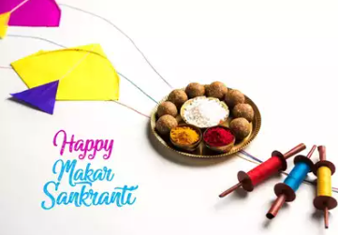
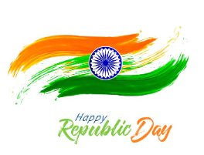

JANUARY & FEBRUARY

ENGLISH | MATHS | HINDI
New Images:  L15. The Ransom of the Red Chief  Novel:  L12 & L-13.  Grammar:  Dialogue, Completion  Phrases, Interjection  Revision for annual examination (worksheets based on yearly topics) | Ch. 12: Ratio and Proportion  Revision of Yearly syllabus. | 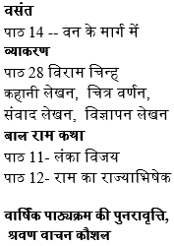
SCIENCE | S.ST. | FRENCH
Ch- 6 The living organisms and the surroundings  Lab Activity:  Presentation on adaptations in aquatic/desert plants and animals. | Pol. Sc.-Ch- 6 Urban Administration  Pol. Sc.-Ch 8 Urban Livelihoods  Revision | Leçon -9  Leçon -10  Ma maison ( All vocabulary)  Les adjectifspossessifs  Ville  Une letter
SANSKRIT |  | G.K.
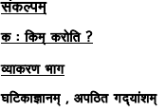 |  | UNIT-8  Brain Waves  45. Testing Reasoning  Pg no. 65  46. Maths Magic Pg no. 66  47. Common Sense Pg no.67  48. Alphabet Quiz Pg no. 68  49. Brain Buzz Pg no. 69  50. I.Q. Test Pg no.70  Worksheets  Pg no.s 76, 77 and 78.

- Computer : Ch – 9 : Understanding the essence of Coding
Ch – 10 : Introducing Python
- Practical : Simple python program

ART & CRAFT | DANCE | MUSIC
Art - Page No. 55(book)& Republic Day drawing & Decorative Art (in file)  Craft -Glass Painting (Warli Art) | Republic day Preparation and Bollywood dance style | Instrumental (Congo, gaiter ,Drum, Casio) ,Prayer, School Songs**

Taekwondo | Yoga | Athletics | Kho- kho | Boxing | Football | Cricket | Basketball | Badminton | Chess | Skating
1. flexibility exercises  2.Back kick | 1 Salabh Asana  2.Dhanur Asana | 1.Running Seating start technic | 1.Pole turn.  2.Chain kho. | 1.Punching with steps. | 1.Control and pass.  2.Dribbling.  3.Shooting. | 1. Bowling  2. Bating | 1. Control the ball with dribbling. | 1. Grip  2. Stance | 1.Strategy  2.Opening & Endgames. | 1.Put on your skating equipment.  2. Assume the right posture.  3. Walk like a duck.

Special Days/ Events | Holidays
- Deworming day  - National science day | 1th to 5th Jan.- Winter Break  15th Jan. - Makar Sankranti  26th Jan. – Republic Day

Looking forward to a fruitful month of learning!

With warm regards,

ROIS

