Date: . .2023
ROYAL OAK INTERNATIONAL SCHOOL
Sr. Sec. C.B.S.E. Affiliated (2023-24)

GRADE – VII MONTHLY PLANNER - 2023

Dear Parents
Greetings!
Please find the academic plan and activities for the month of January and February.

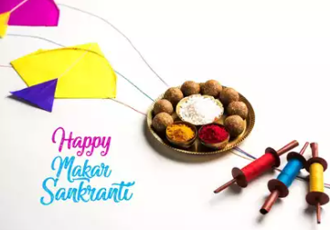

JANUARY & FEBRUARY

ENGLISH | MATHS | HINDI
New Images:  L16 Shilong: The Rock Capital of India  Grammar:  Clauses & Grammar on the go Words: A Mixed Bag, Narration | Ch.13: Visualising solid shapes  Revision of Yearly syllabus. | 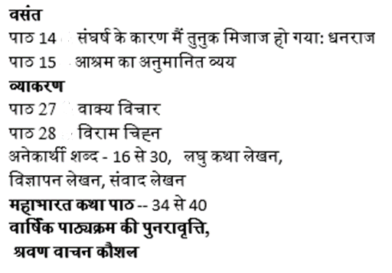
SCIENCE | S.ST. | FRENCH
Ch -13 Wastewater Story  Lab Activity:  Role play of methods involved in Wastewater Treatment Plant | Pol. L-7 Markets Around Us  - Revision | Leçon 12:Une visite au parcd’attractions  Passé composé(Être)  Passé composé ( avoir )  Passé composé ( Irregular avoir verb)
SANSKRIT |  | G.K.
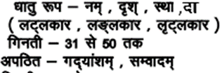 |  | UNIT-8  Brain Waves  43. Mind Bogglers Pg no. 65  44. Number Puzzles Pg no. 66  45. IQ Testing Pg no.67  46 . Work It out Pg no. 68  47. Think Before you Answer Pg no. 69  48. Language Quiz Pg no.70  Worksheets  Pg no.s 76, 77 and 78.

- Computer : Ch-9 Understanding Google sheets
Ch-10 App Development
- Practical : Create an app to display the capital of five countries

ART & CRAFT | DANCE | MUSIC
Art - Page no:64,65(Book) & Republic Day drawing (in file)  Craft -Sculpture with Clay | Republic day Preparation and Bollywood dance style | Instrumental (Congo, gaiter ,Drum, Casio) ,Prayer, School Songs**

Taekwondo | Yoga | Athletics | Kho- kho | Boxing | Football | Cricket | Basketball | Badminton | Chess | Skating
1. flexibility exercises  2.Back kick | 1 Salabh Asana  2.Dhanur Asana | 1.Running Seating start technic | 1.Pole turn.  2.Chain kho. | 1.Punching with steps. | 1.Control and pass.  2.Dribbling.  3.Shooting. | 1. Bowling  2. Bating | 1. Control the ball with dribbling. | 1. Grip  2. Stance | 1.Strategy  2.Opening & Endgames. | 1.Put on your skating equipment.  2. Assume the right posture.  3. Walk like a duck.

Special Days/ Events | Holidays
- Deworming day  - National science day | 1th to 5th Jan.- Winter Break  15th Jan. - Makar Sankranti  26th Jan. – Republic Day

Looking forward to a fruitful month of learning!

With warm regards,

ROIS

